**PEMROGRAMAN JARINGAN**

**TUGAS 10 : PERFORMANCE TEST**



**DISUSUN OLEH :**

**NAMA : CELIA CHINTARA YUWINE**

**NRP : 05111740000058**

**KELAS : B**

**DEPARTEMEN TEKNIK INFORMATIKA**

**FAKULTAS TEKNOLOGI ELEKTRO DAN INFORMATIKA CERDAS**

**INSTITUT TEKNOLOGI SEPULUH NOPEMBER (ITS) SURABAYA**

**SEMESTER GENAP**

**TAHUN PELAJARAN 2019/2020**

**TUGAS 10**

1. Pull update terbaru
2. Jalankan async_server.py pada port 9002, 9003, 9004, 9005 (lihat pada BackendList)
3. Jalankan file lb.py, jalankan di port 44444
4. Jalankan browser, akseslah <http://localhost:44444/page.html>
5. Lihatlah di log program, bahwa setiap request akan dilayani oleh backend yang bergantian
6. Lakukan performance test seperti pada tugas 9, bandingkan penggunaan load balancer dengan async_server dengan server_thread_http pada folder progjar5
7. Buatlah tabel hasilnya

**Jawaban:**

1. **Jalankan async_server.py pada port 9002,9003,9004, dan 9005 dengan menjalankan file runserver.sh dengan command “bash runserver.sh”**

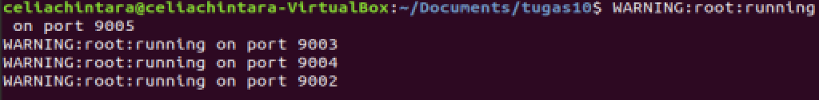

1. **Jalankan file lb.py pada port 44444**

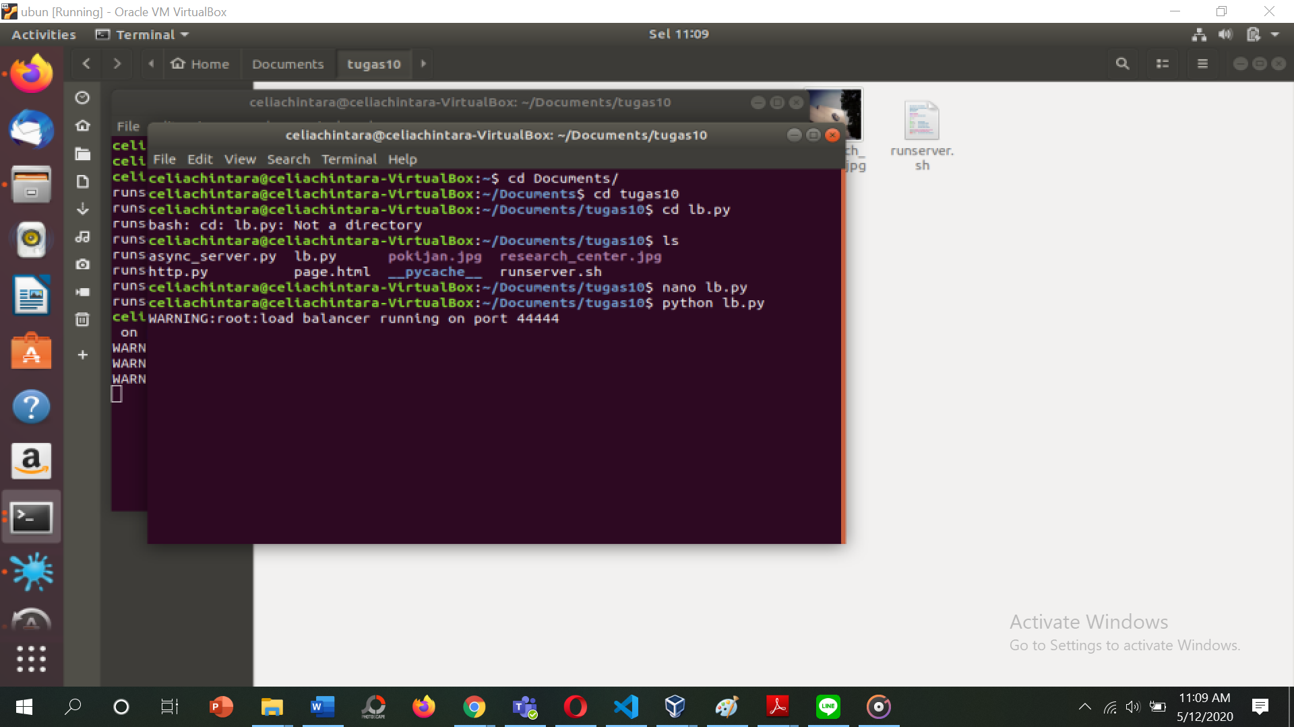

1. **Akses halaman** [**http://localhost:44444/page.html**](http://localhost:44444/page.html)



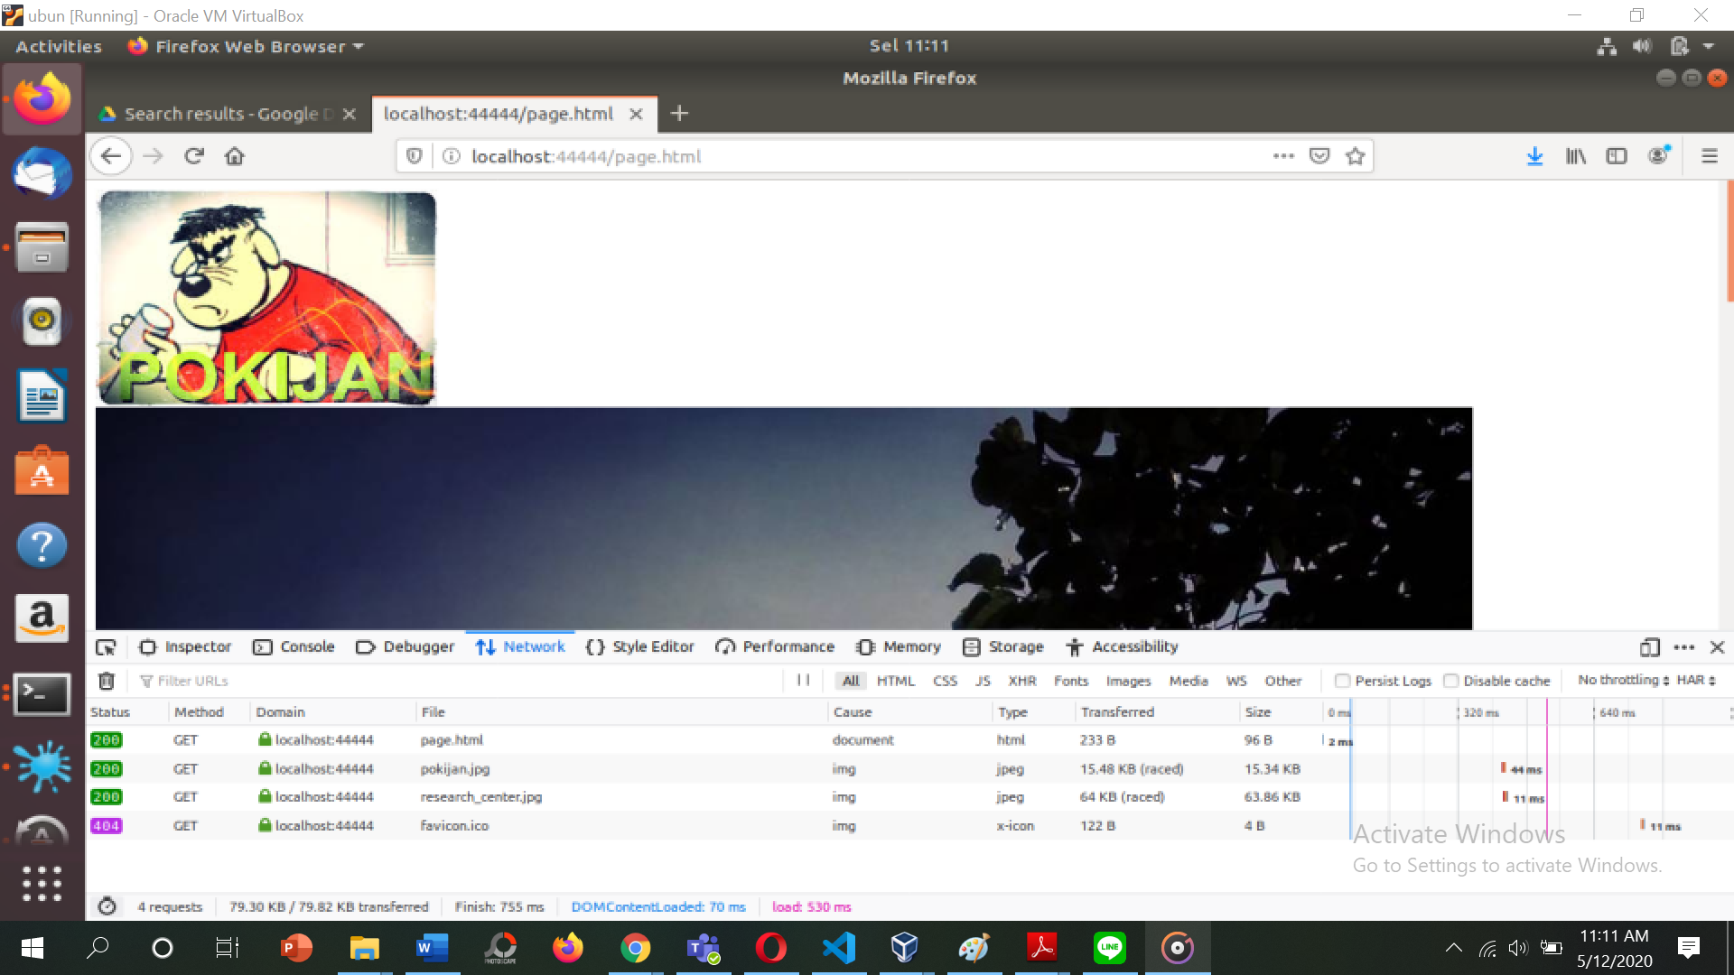

1. **Lihat log program, bahwa setiap request akan dilayani oleh backend yang bergantian**

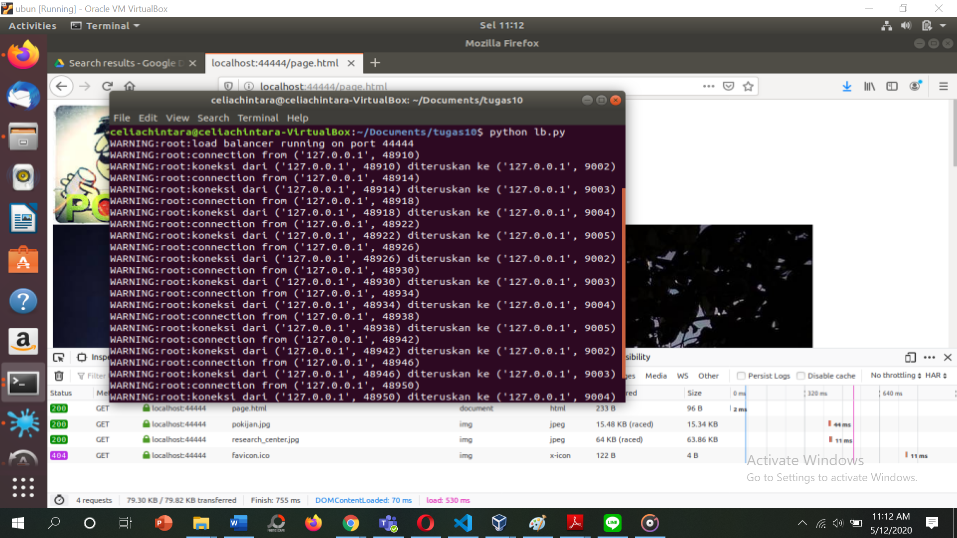

1. **Performance Test**

Atur request sebesar 1000 request

* 1. **server_async_http.py pada port 45000**

|  |  |  |  |  |  |  |  |  |
| --- | --- | --- | --- | --- | --- | --- | --- | --- |
| No test | Concurrency Level | Time taken for test (second) | Complete request | Failed request | Total transferred (bytes) | Request per second [#/sec] | Time per request [ms] | Transfer rate [Kbytes/sec] |
| 1 | 1 | 2.216 | 1000 | 0 | 122000 | 451.32 | 2.216 | 53.77 |
| 2 | 5 | 2.482 | 1000 | 0 | 122000 | 402.95 | 2.482 | 48.01 |
| 3 | 10 | 2.646 | 1000 | 0 | 122000 | 377.99 | 2.646 | 45.03 |
| 4 | 15 | 1.904 | 1000 | 0 | 122000 | 525.09 | 1.904 | 62.56 |
| 5 | 50 | 14.307 | 1000 | 0 | 122000 | 69.89 | 14.307 | 8.33 |
| 6 | 100 | 55.941 | 1000 | 0 | 122000 | 17.88 | 55.941 | 2.13 |

* 1. **Level concurrency 1**

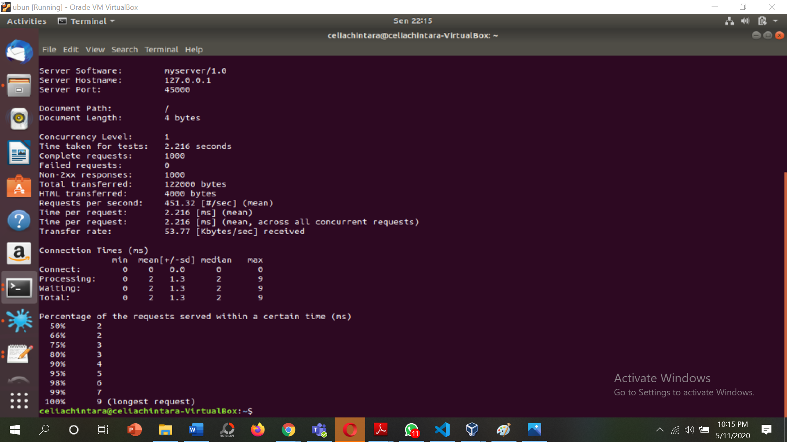

* 1. **Level concurrency 5**

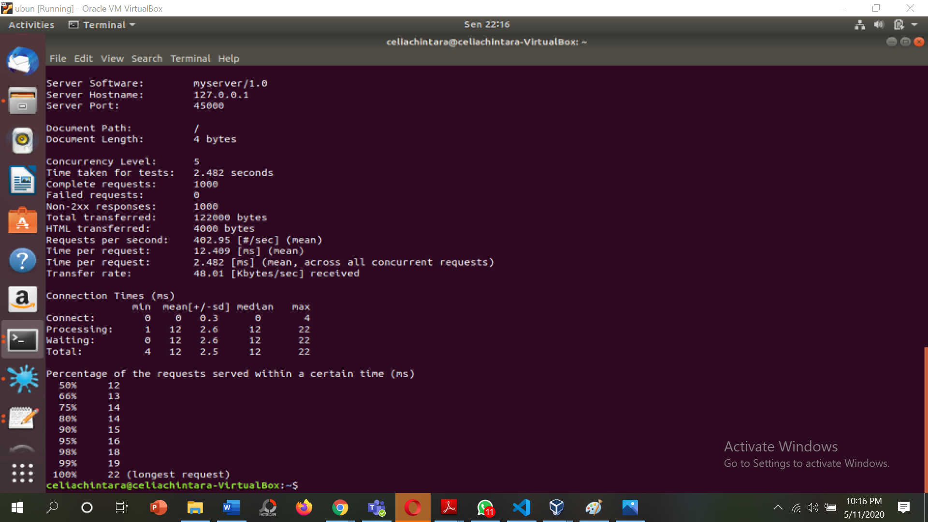

* 1. **Level concurrency 10**

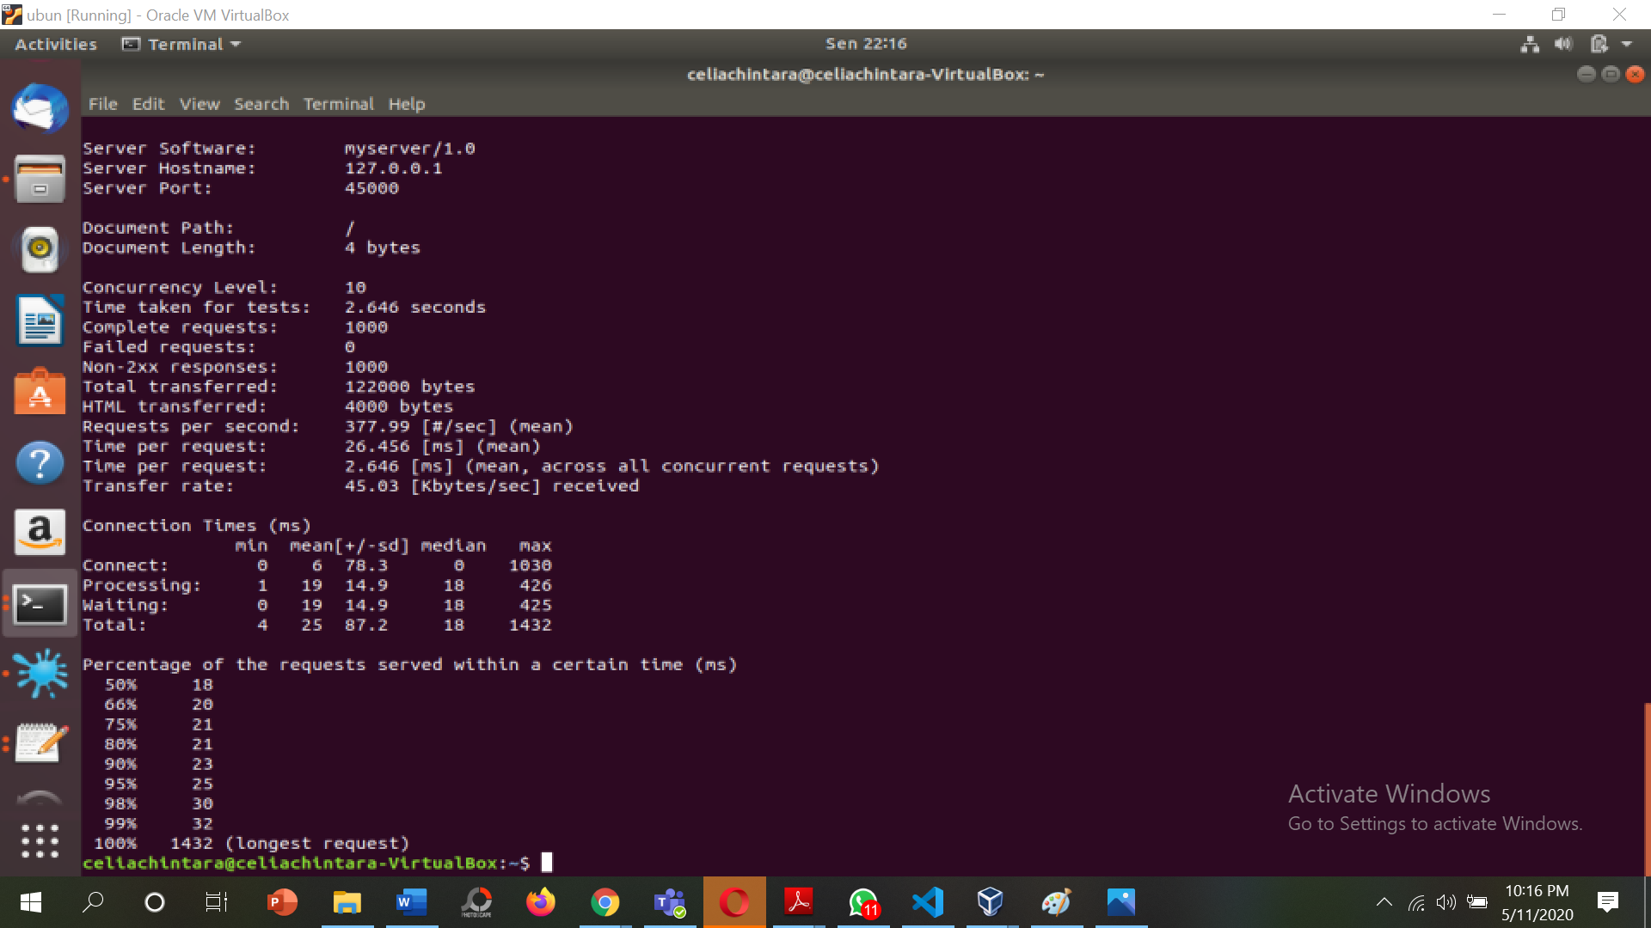

* 1. **Level concurrency 15**

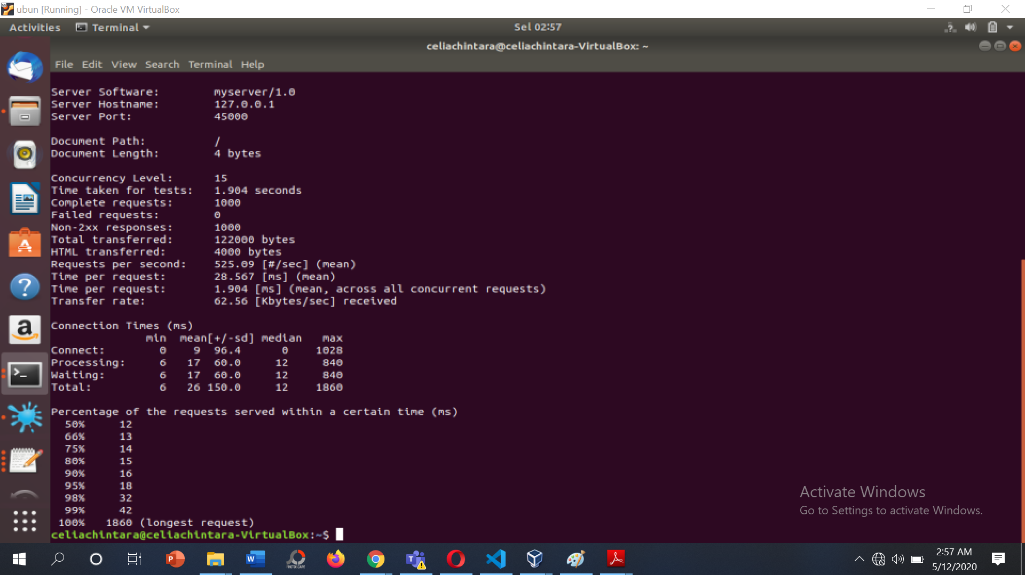

* 1. **Level concurrency 50**

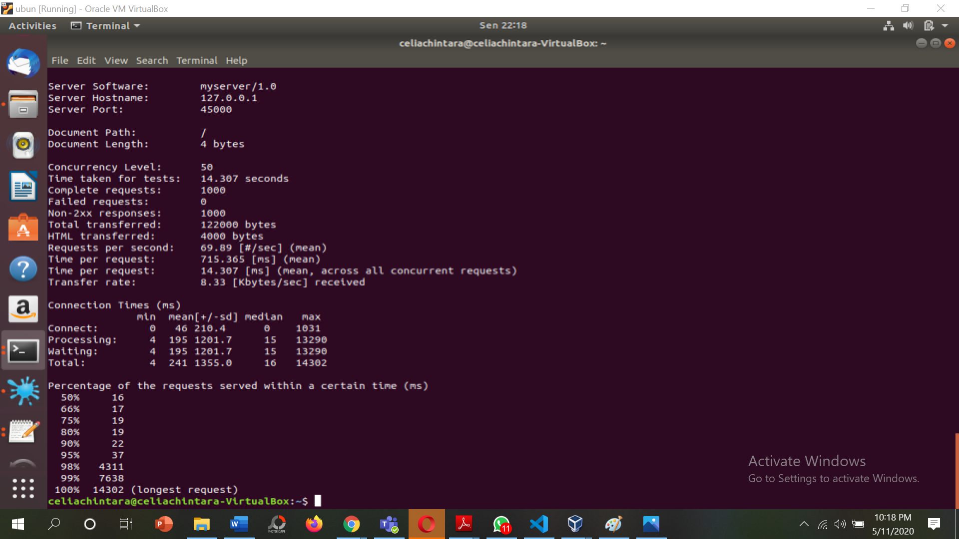

* 1. **Level concurrency 100**

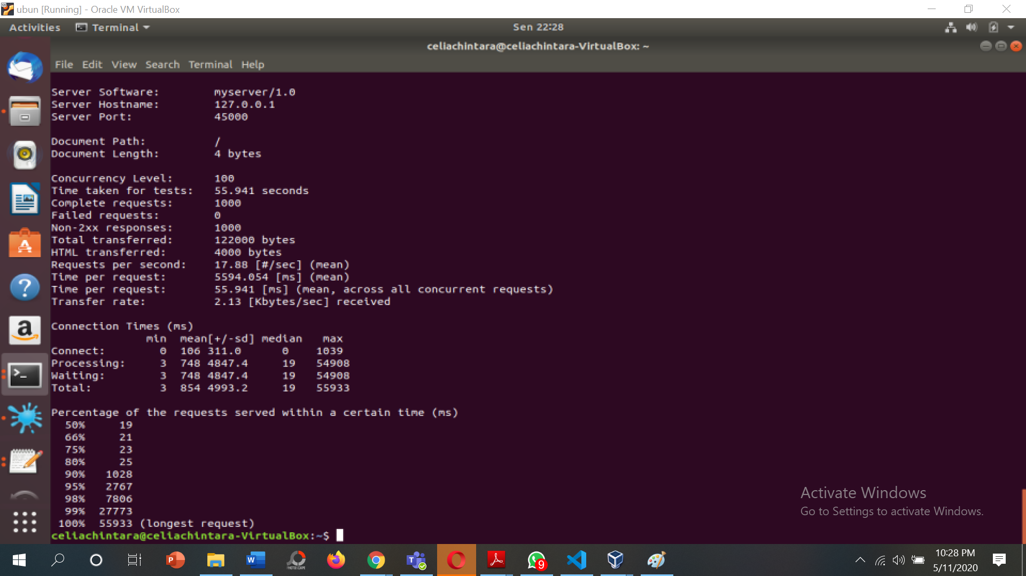

* 1. **server_thread_http.py pada port 46000**

|  |  |  |  |  |  |  |  |  |
| --- | --- | --- | --- | --- | --- | --- | --- | --- |
| No test | Concurrency Level | Time taken for test (second) | Complete request | Failed request | Total transferred (bytes) | Request per second [#/sec] | Time per request [ms] | Transfer rate [Kbytes/sec] |
| 1 | 1 | 2.278 | 1000 | 0 | 122000 | 439.02 | 2.278 | 52.31 |
| 2 | 5 | 3.476 | 1000 | 0 | 122000 | 287.71 | 3.476 | 34.28 |
| 3 | 10 | 3.486 | 1000 | 0 | 122000 | 286.88 | 3.486 | 34.18 |
| 4 | 15 | 3.865 | 1000 | 0 | 122000 | 258.76 | 3.865 | 30.83 |
| 5 | 50 | 7.806 | 1000 | 0 | 122000 | 128.11 | 7.806 | 15.26 |
| 6 | 100 | 4.372 | 1000 | 0 | 122000 | 228.74 | 4.372 | 27.25 |

1. **Level concurrency 1**

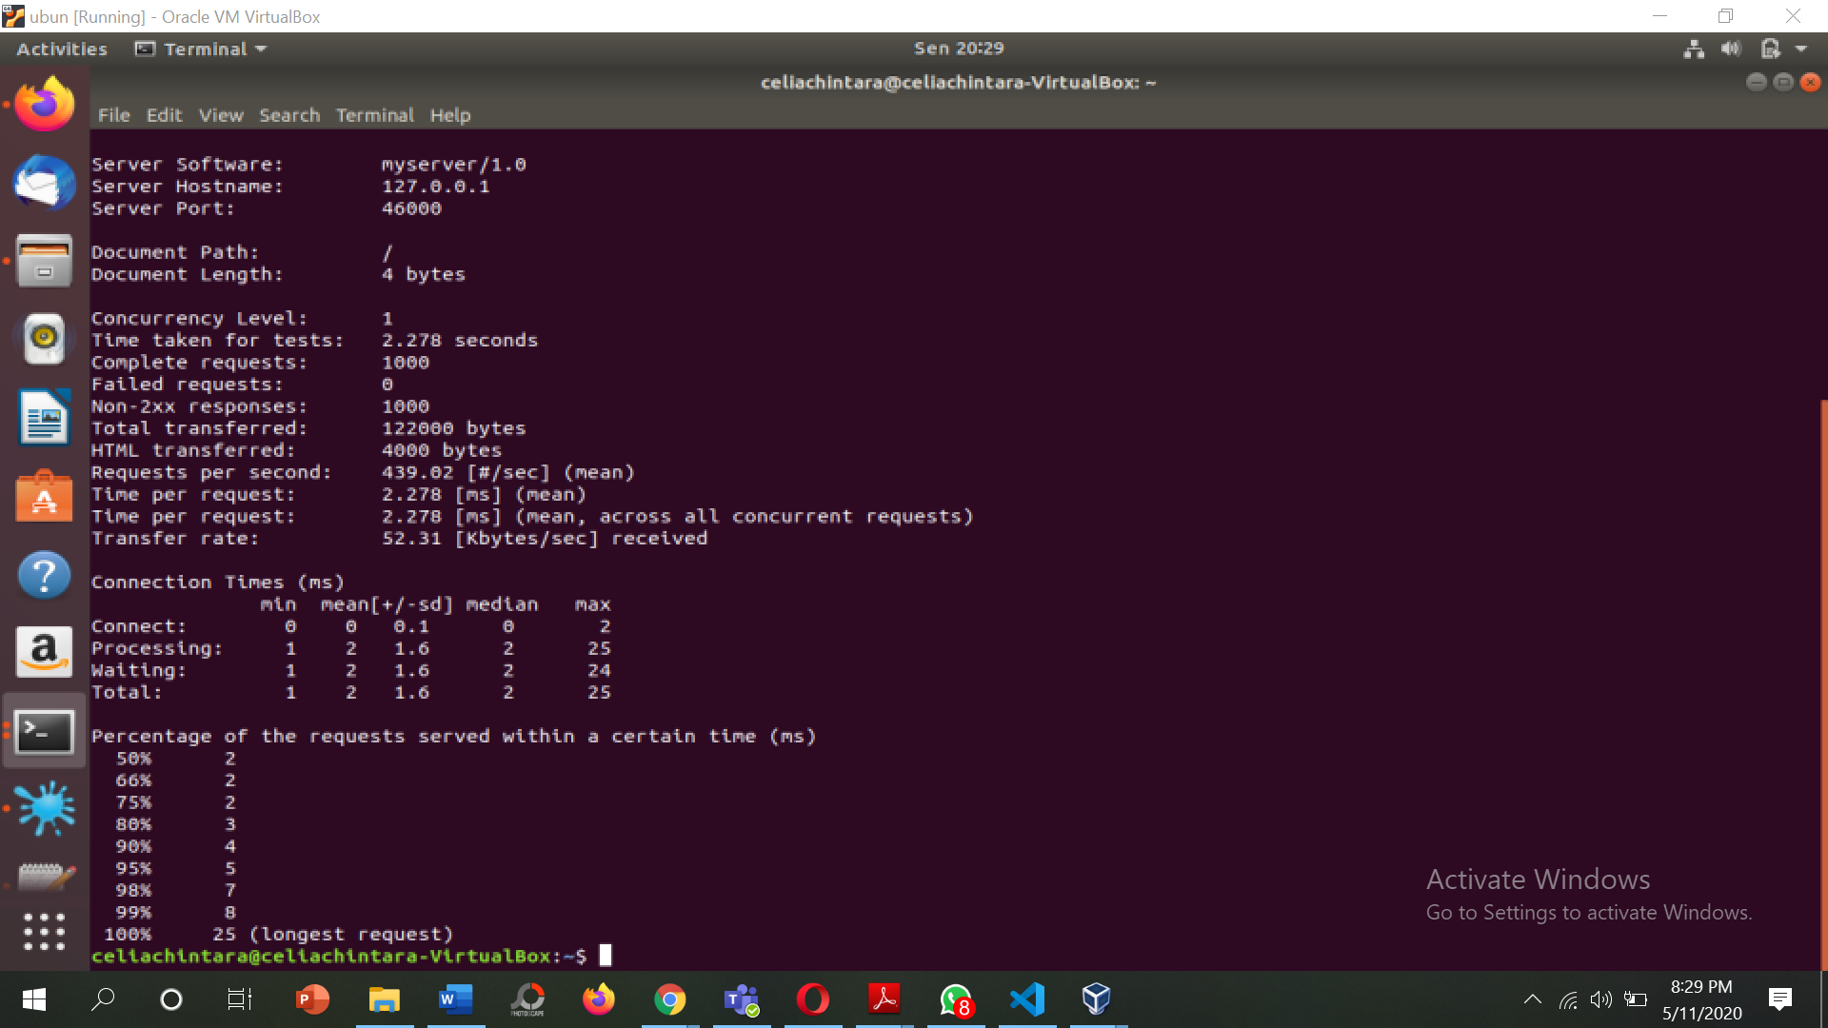

1. **Level concurrency 5**

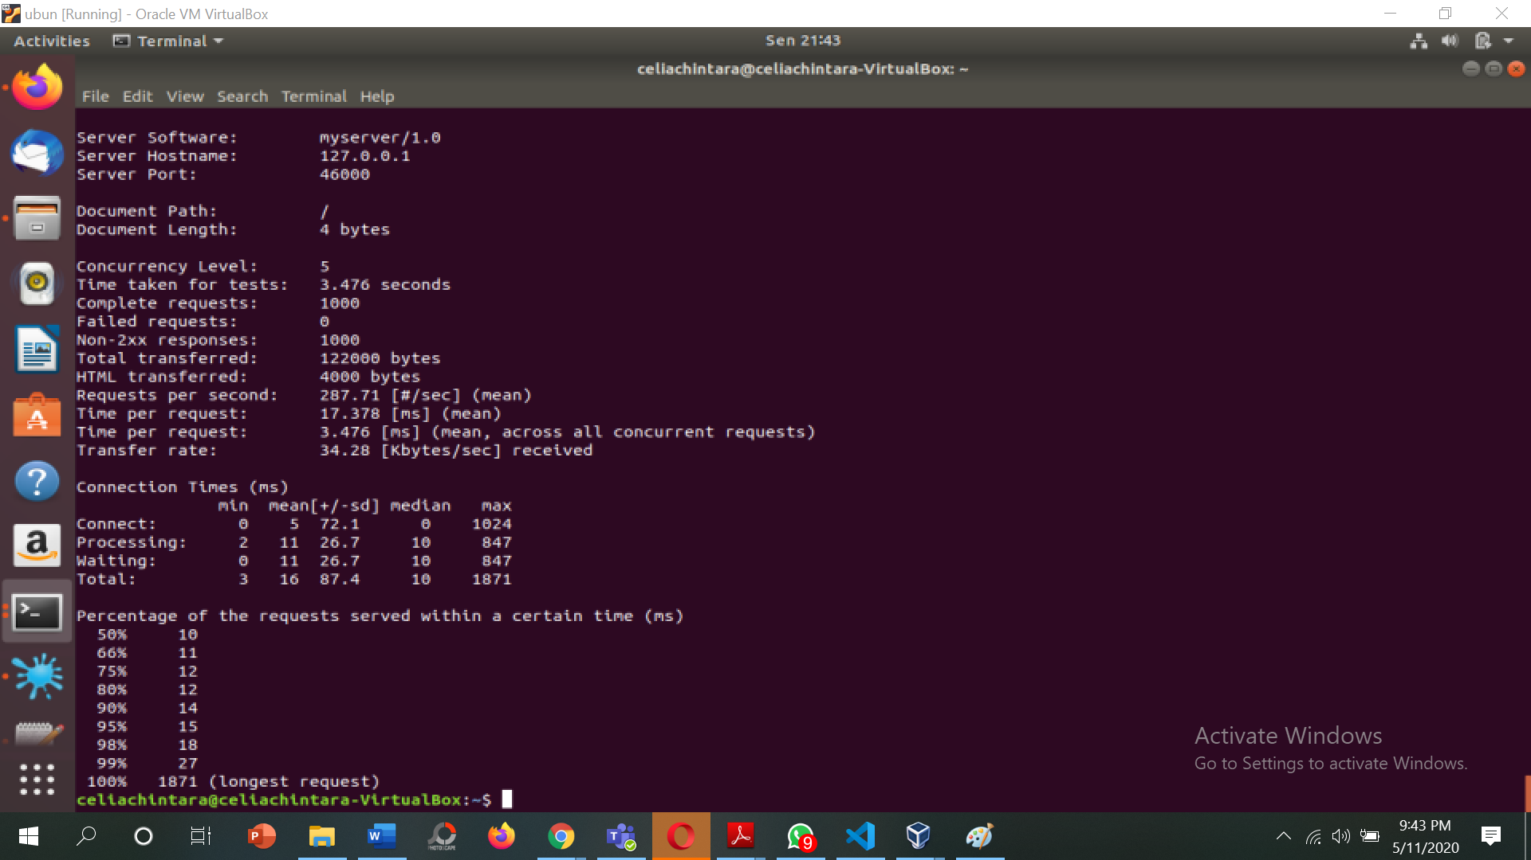

1. **Level concurrency 10**

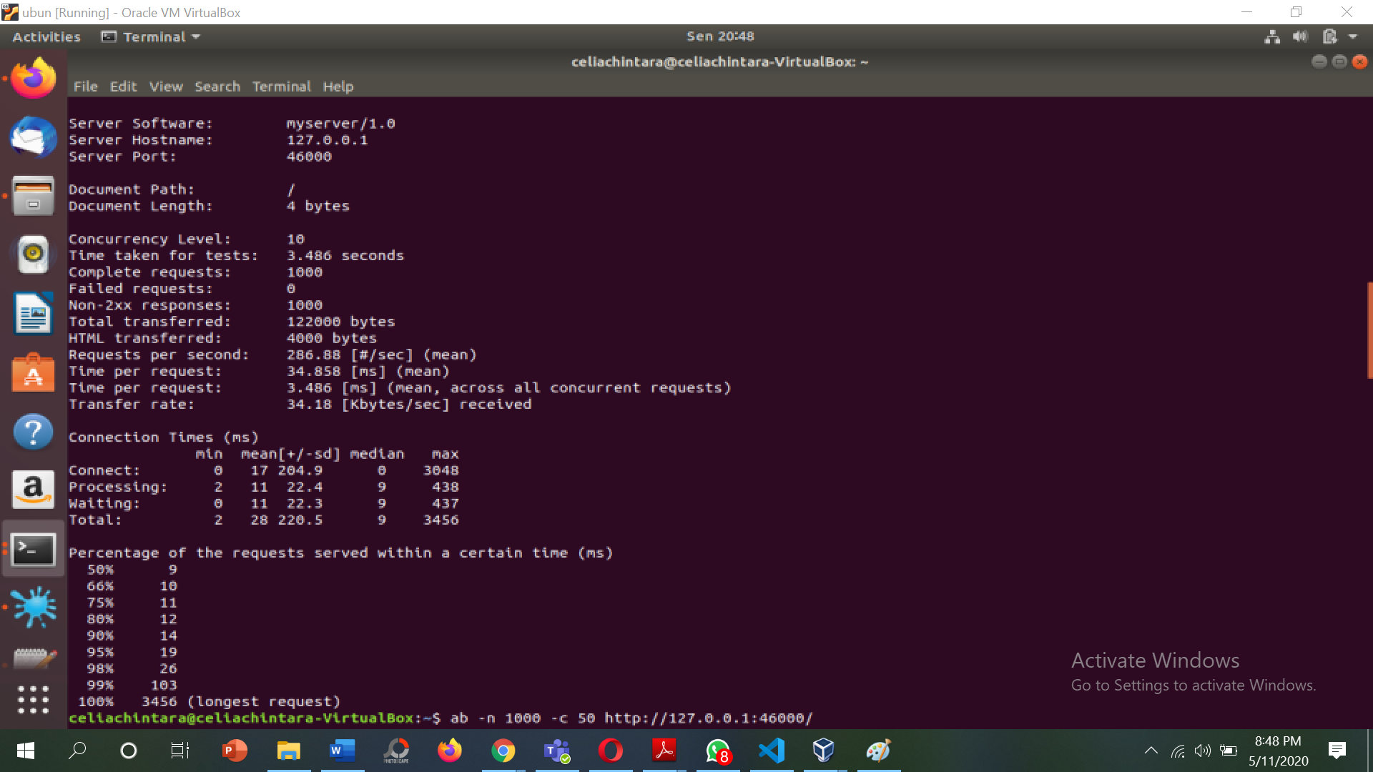

1. **Level concurrency 15**

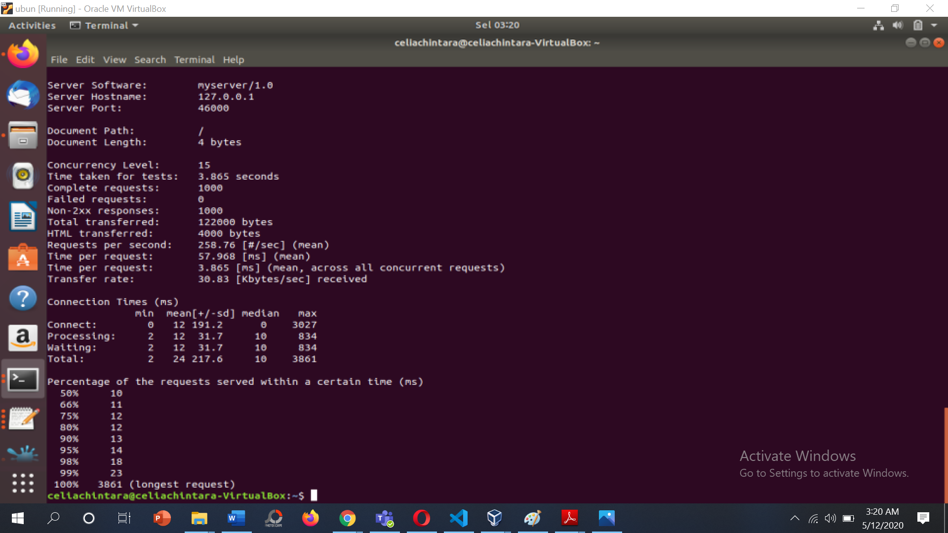

1. **Level concurrency 50**

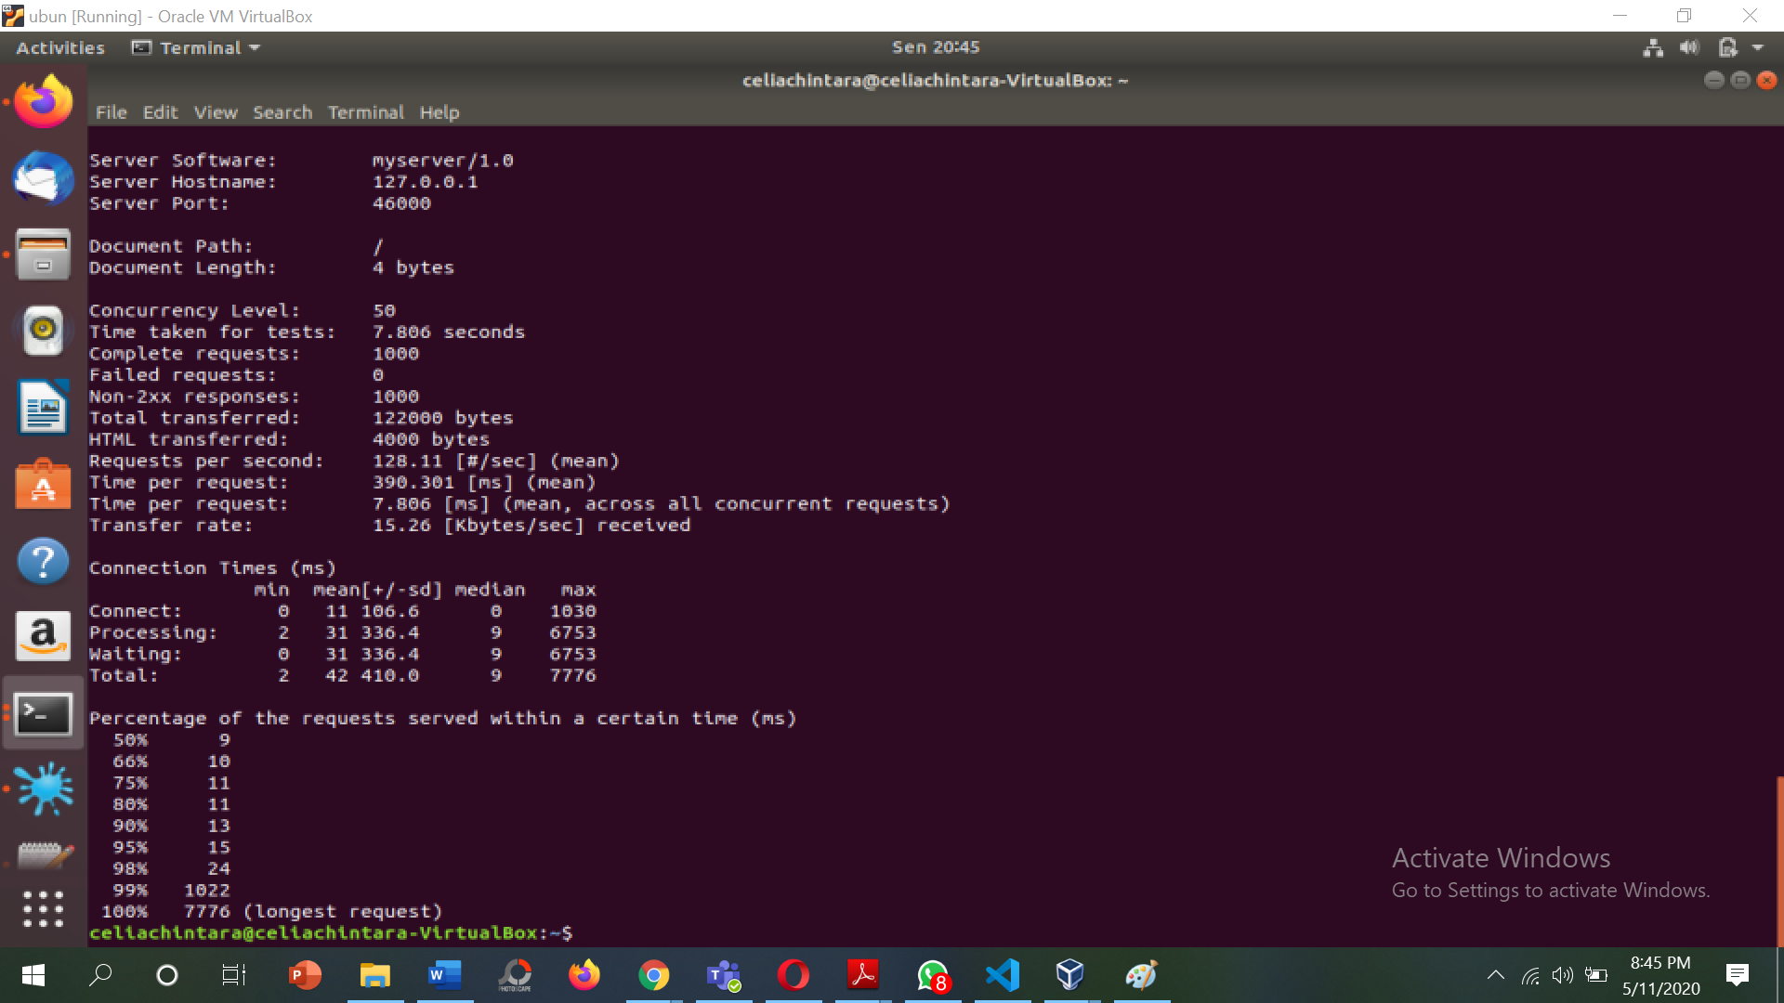

1. **Level concurrency 100**

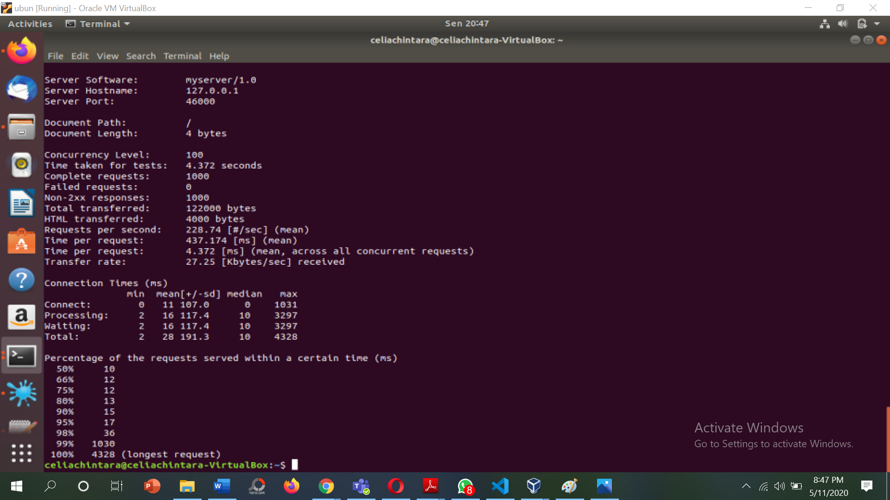

* 1. **load balancer pada port 44444**

|  |  |  |  |  |  |  |  |  |
| --- | --- | --- | --- | --- | --- | --- | --- | --- |
| No test | Concurrency Level | Time taken for test (second) | Complete request | Failed request | Total transferred (bytes) | Request per second [#/sec] | Time per request [ms] | Transfer rate [Kbytes/sec] |
| 1 | 1 | 2.417 | 1000 | 0 | 122000 | 413.69 | 2.417 | 49.29 |
| 2 | 5 | 1.988 | 1000 | 0 | 122000 | 502.97 | 1.988 | 59.92 |
| 3 | 10 | 2.459 | 1000 | 0 | 122000 | 406.66 | 2.459 | 48.45 |
| 4 | 15 | 2.216 | 1000 | 0 | 122000 | 451.35 | 2.216 | 53.77 |
| 5 | 50 | 54.132 | 1000 | 0 | 122000 | 18.47 | 54.132 | 2.20 |
| 6 | 100 | 173.820 | 969 | 31 | 118218 | 5.57 | 179.380 | 0.66 |

1. **Level concurrency 1**

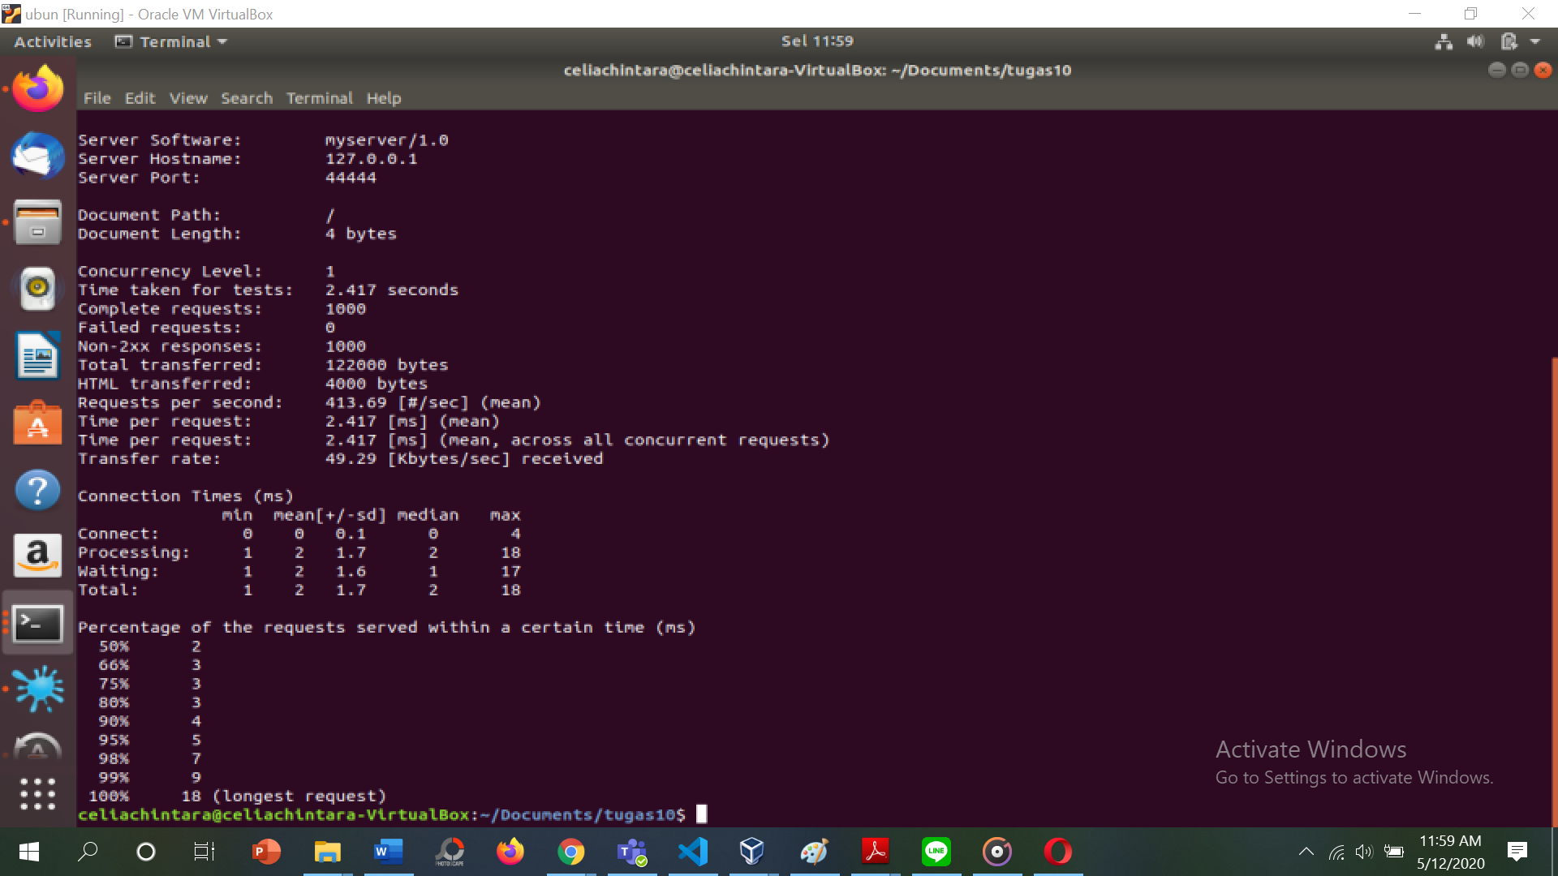

1. **Level concurrency 5**

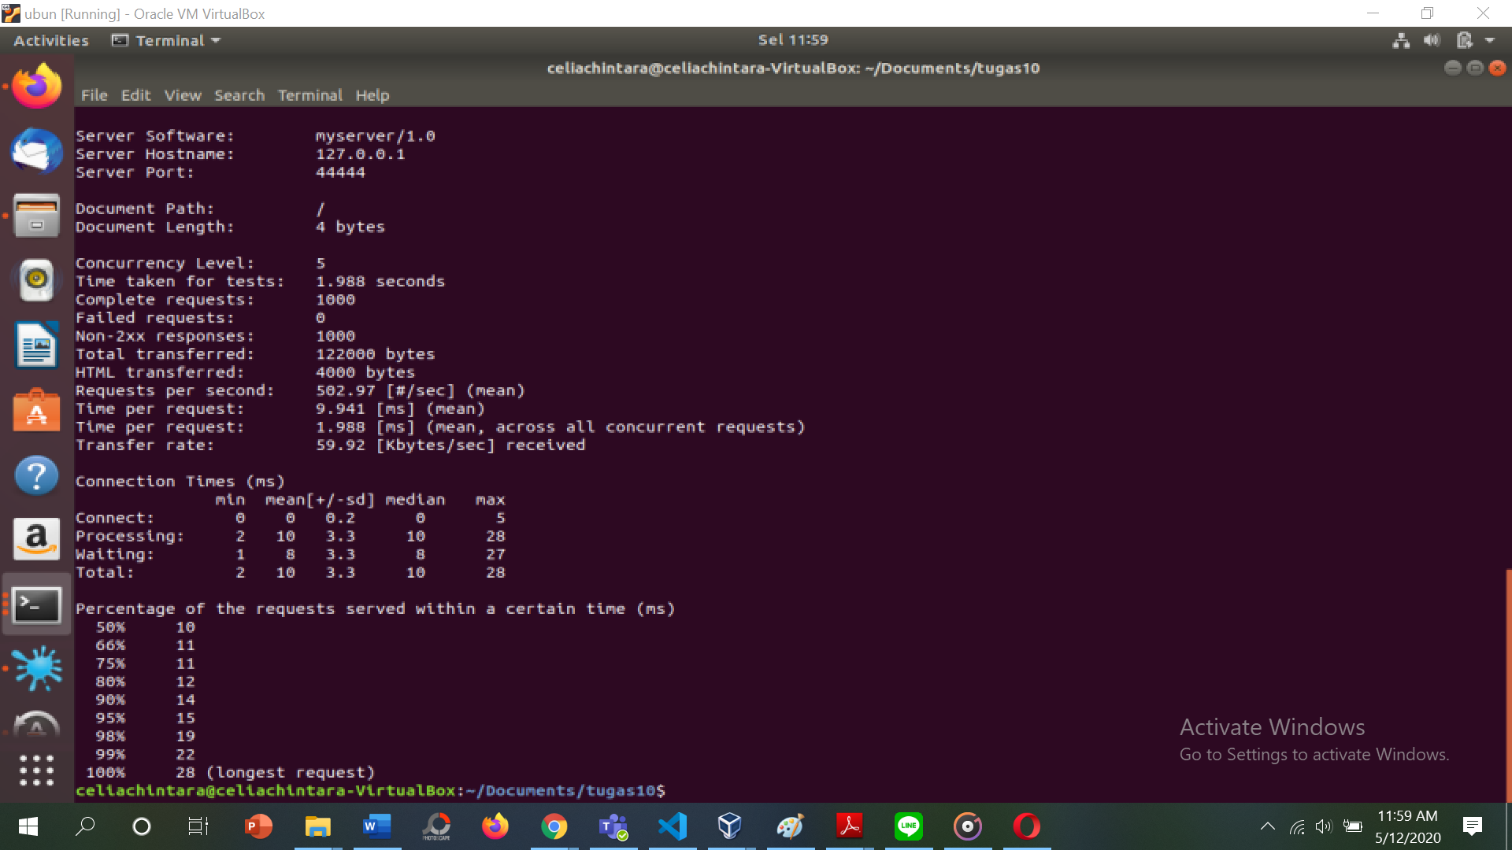

1. **Level concurrency 10**

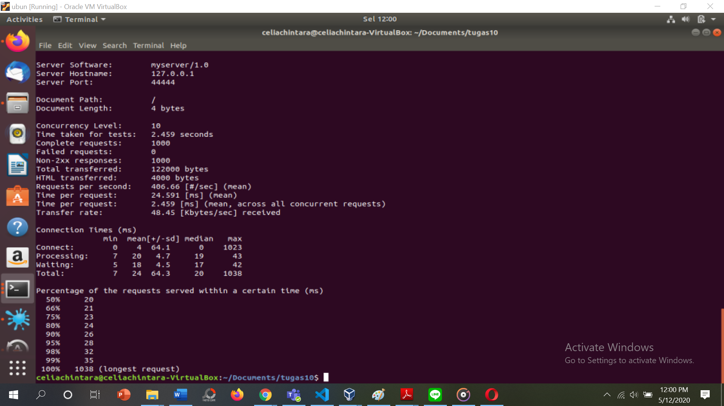

1. **Level concurrency 15**

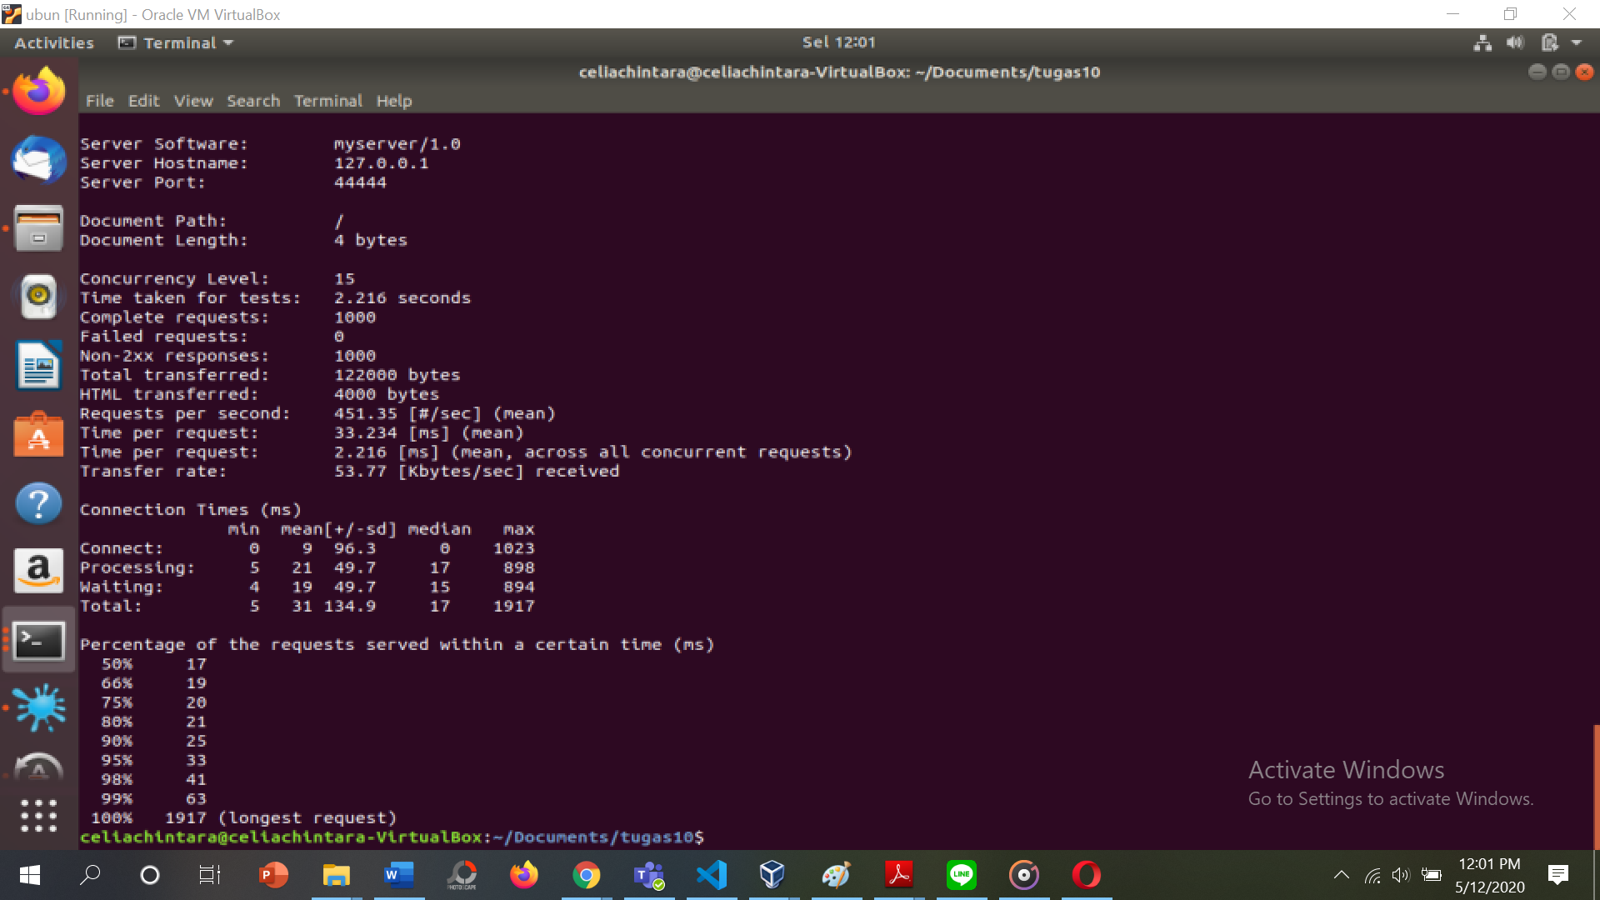

1. **Level concurrency 50**

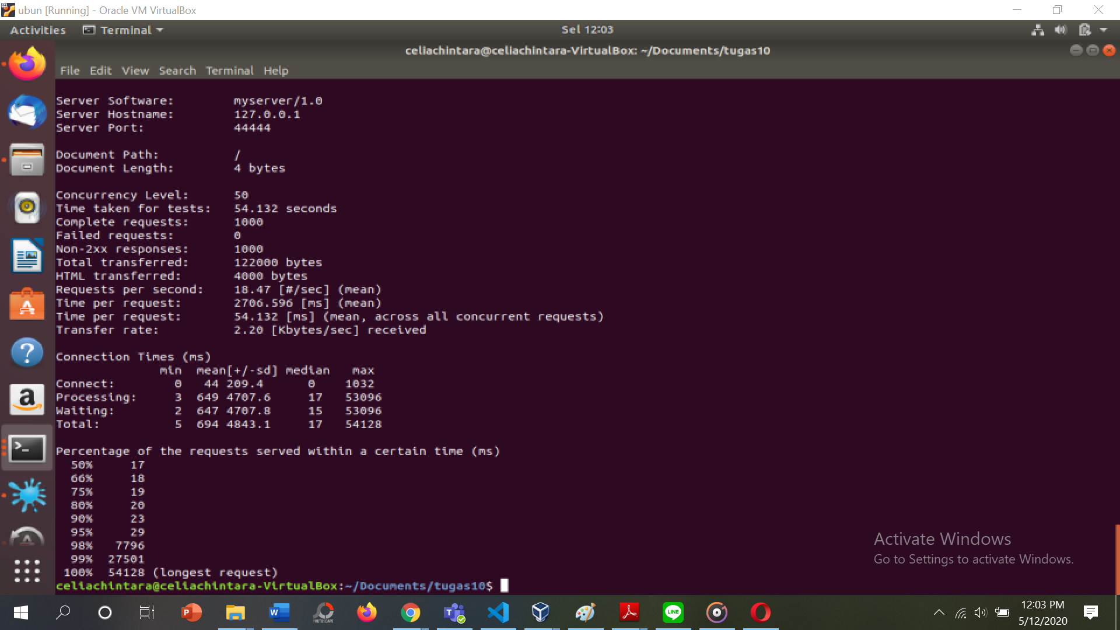

1. **Level concurrency 100**

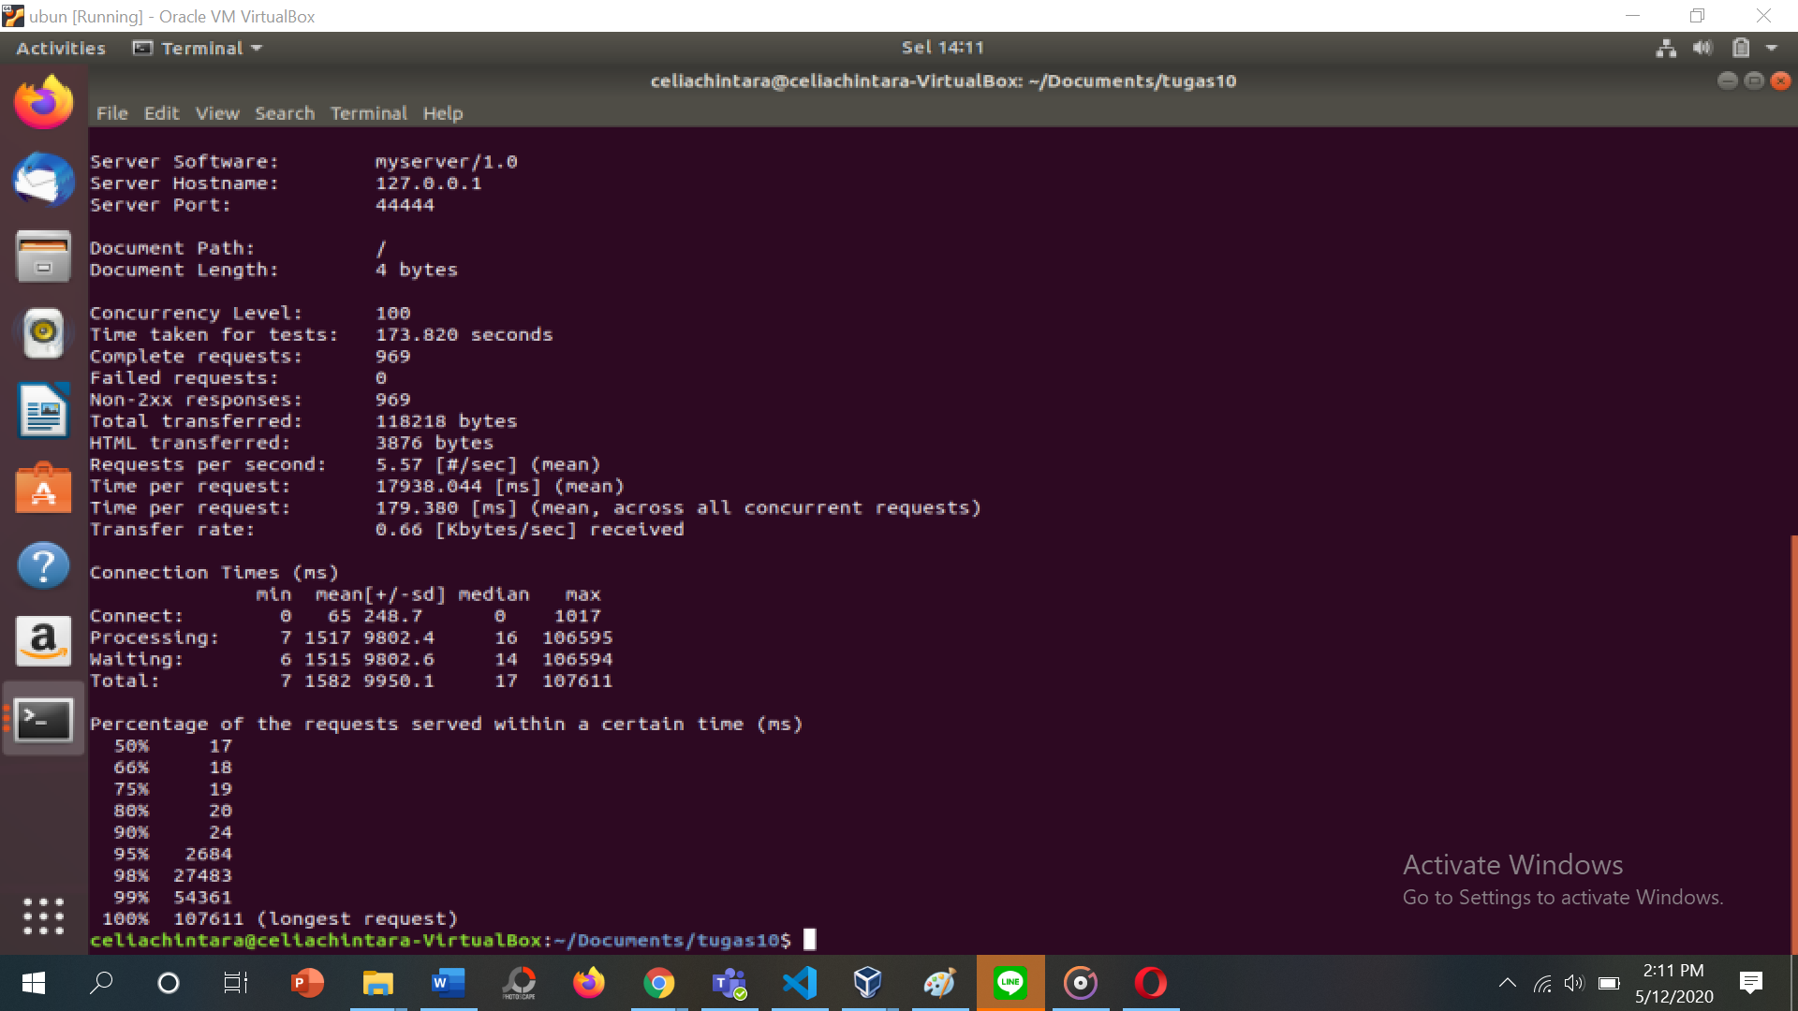

1. **Kesimpulan**

Dari hasil performance test pada server async, server thread, dan dengan load balancer, dapat dilihat dari hasil yang tertera pada table-table diatas bahwa server dengan load balancer memiliki performa yang lebih baik dari pada server yang lainnya.